HAL Properties Limited

Request for Proposal (RFP) for
Straw and Artisan Market
at RelaxAway Half Moon Cay

December 2025

I. GENERAL

A. INTRODUCTION

HAL Properties Limited, a subsidiary of Carnival Corporation & plc, invites proposals from qualified vendors for the leasing and operation of artisan/straw market stalls at RelaxAway Half Moon Cay (the “Destination”), The Bahamas. The goal is to provide local artisans and small retailers the opportunity to sell authentic Bahamian goods to cruise guests, while adhering to HAL Properties Limited’s guidelines for pricing, structure, and operations.

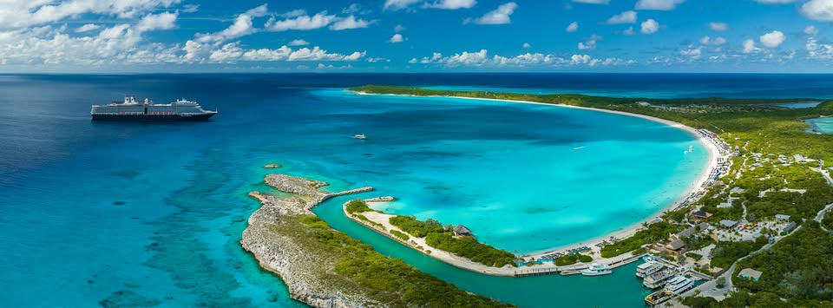

B. BACKGROUND & PROJECT LOCATION

- Carnival Corporation & plc and HAL Properties

Carnival Corporation & plc, the world’s largest leisure travel company, provides travelers around the globe with extraordinary vacations at an exceptional value. The company’s portfolio of global cruise line brands includes eight (8) distinct brands operating worldwide. Together, these brands form the world’s largest cruise company with a fleet of over 90 ships visiting more than 700 ports around the world. For more information, please visit http://www.carnivalcorporation.com/.

The Destination is operated by HAL Properties Limited and is designed primarily to serve Carnival Cruise Line, Holland America Line and Princess Cruises. Carnival Cruise Line is “The World’s Most Popular Cruise Line” and currently operates 25 ships on three to 24-day voyages worldwide. Holland America Line currently operates 11 modern classic ships and offers more than 500 sailings a year, visiting all seven continents. Princess Cruises, the original “Love Boat”, operates a fleet of 17 ships with a presence in every region of the globe. For more information, please visit http://www.carnival.com, https://www.hollandamerica.com/ and https://www.princess.com .

- Project Location
RelaxAway Half Moon Cay is located on Little San Salvador Island in The Bahamas. It is a cruise port destination owned and operated by HAL Properties Limited. This Project is located in the northwest side of the Island (the “New Development”), which will include a pier that can accommodate up to 2 ships, larger retail operation and various F&B outlets. The southeast, existing development is currently operating and is not subject to this RFP. The New Development is designed to berth Carnival’s largest ship class.
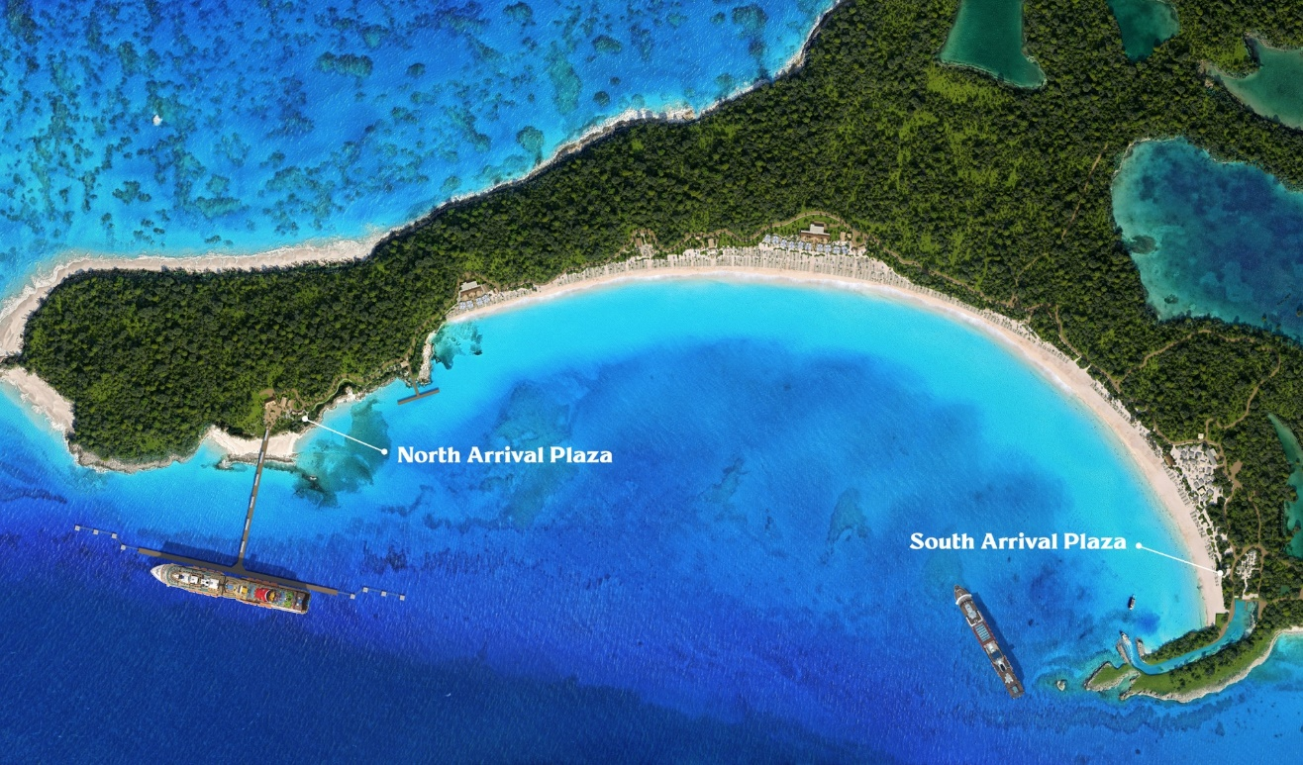

C. PROJECT DESCRIPTION

- Objective

Half Moon Cay North is a dedicated cruise ship destination designed to accommodate up to two cruise ships per day, with a daily onshore capacity of up to 8,000 guests. We expect 1.5M+ passengers annually, and we expect to have ship calls most days of the year, including holidays.

The New Development is scheduled to open in June 2026.

This RFP is for Straw and Artisan Market vendors at the New Development. HAL Properties Limited plans to negotiate and execute a lease agreement with qualified Operators. The commercial agreement(s) will ask the Operator(s) to participate in setup, full operation, the stall upkeep (cleanliness) and selling authentic straw and artisan items at the New Development.

For more information, please https://www.halfmooncayport.com/ and follow us on social media:
- Instagram: https://www.instagram.com/explore/locations/257214333/half-moon-cay-bahamas/?hl=en
- Facebook: https://www.facebook.com/profile.php?id=61559732984122
- LinkedIn: https://www.linkedin.com/company/relaxaway-half-moon-cay/

- Extent and Scope of the Project

The Straw and Artisan Market will be available to several thousand guests and crew across a variety of daily operational scenarios. The Destination will primarily receive ships during the day (8 a.m. to 5 p.m.). Transportation for Operators to and from New Development will be via a clipper departing from and returning to Princess Cays near Bannerman Town in Eleuthera, The Bahamas.

The successful Operators must exhibit the experience and capability of generally providing Bahamian focused and/ or inspired goods for straw and artisan market stalls; while demonstrating the ability to properly stock and replenish their inventory of goods so there are no business interruptions. Also, Operators are expected to price their goods competitively and remain below the identified price ceiling of $65. It is HAL Properties’ objective to select an Operator for each available stall.

The scope of this RFP includes:
- Operate a Straw and artisan Stall within the designated area of the New Development.
- Maintain a clean and neat work area.
- Ensure compliance with local safety and sustainability regulations.
- Collaborate with RelaxAway Half Moon Cay’s operations team to align with brand and guest experience standards.

Interested parties should note:
- Only Bahamian owned and operated businesses qualify.
- Setup, operations and stall maintenance shall comply with applicable requirements of HAL Properties Limited Rules and Regulations.
- New Development will be open nearly every day, so all retails stalls must be open and operating every day the port is open without exceptions.
- Each operator will be required to follow HAL Properties Limited’s Safety and Environmental strict requirements, which will be audited frequently.

Guests will be charged directly by the Operator for all purchases, via credit card (as long as the credit card device is P2PE certified) and cash.

- Evaluation Criteria
Request for Proposal evaluation will be based on all elements of each response, including intangible factors such as HAL Properties Limited’s assessment of each Operator’s ability to meet its commitments. Responses not meeting Minimum Requirements may be disqualified and may not be considered for award. As aforementioned, HAL Properties Limited is looking for reliable, financially stable Operators who can meet or exceed HAL Properties Limited’s stringent cost, quality, and service requirements. Specifically, these requirements are:
- Minimum Requirements
  - Complete responses must be received on or before the due date.
  - Responses must include all required information asked in the RFP questionnaire worksheet.
  - Operators must read and follow all instructions and guidelines.
  - Operators must provide pictures of products with description and price

Proposals will be evaluated based on:
- Bahamian-owned and operated
- Currently operating or ready to operate a retail business
- Experience and pictures of authentic, Bahamian made and/ or inspired items
- Hold a valid business license (or willing to obtain the proper license)
- Ability to meet insurance requirements
- Ability to comply with local health and safety regulations
- Ability to start immediately after selection.

- Proposed Project Schedule:

For this Request for Proposal, HAL Properties has established the following timeline for the completion of the RFP process. Potential Operators not responding by these due dates may be disqualified:

Sourcing Process | Due Date
Request for Proposal Posted on social media pages | 12/19/2025
HAL Properties townhall to be held in Eleuthera | TBD – January 2026
Operator Questions Due to HAL Properties Limited | 1/15/2026
HAL Properties Limited Answers to Operators | 1/22/2026
RFP Responses Due | 1/31/2026
HAL Properties Limited RFP Review and Evaluation | By 2/13/2026
Operator Presentations (if asked for by HAL Properties Limited) | 2/16- 2/27/2026
Preferred Operator(s) selected | 3/10/2026
Business Award Notification sent | 3/23/2026
Finalize Leasing Agreements | 04/17/2026

- REQUIRED SUBMITTALS

Respondents must complete the attached Excel questionnaire and include:

- Business profile and ownership details
- Retail concept description with visuals
- Product origin and sustainability details
- Inventory management plan
- Licensing and insurance (if available)
- Pricing strategy
Information is to be submitted by close of business on January 31, 2026. Interested Operators are requested to submit their information, which must include and reference the elements included in the RFP Response Outline (Exhibit A), via email to eclaxton@carnival.com and destination_concessions@carnival.com.

Any questions or issues should be addressed via e-mail to eclaxton@carnival.com. All information provided will be held confidentially by HAL Properties Limited.

EXHIBIT A: ATTACHMENT 1

Appendix
EXHIBIT 1 - Statement of Work (SOW)

Straw Market for RelaxAway Half Moon Cay North

Overview

This Statement of Work (SOW) outlines the specifications for the development, operation, and leasing of Straw market stalls at New Development, a cruise destination on Little San Salvador Island in The Bahamas. The purpose of this initiative is to provide local artisans and small retailers with an opportunity to sell goods to visitors in designated markets and retail areas while maintaining specific guidelines related to pricing, structure, and operational hours.
This SOW outlines the key responsibilities and expectations for operators to lease straw market stalls at the cruise destination. Detailed lease agreements and pricing structures will be provided during the finalization phase of this project.

- Straw Market Stalls

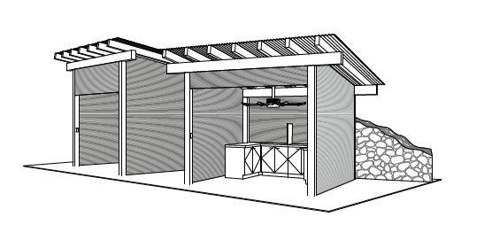

1.1. Quantity and Location
There are 8 total Straw market and Artisan stalls:
Each stall has a general dimension of approximately 10’ x 5’. The market area is open-air, with fans installed for ventilation and comfort.

1.2. Structure and Design
- Each stall will be equipped with an entrance to facilitate transactions and customer engagement. The stall will include lower cabinets for storage
- The stalls are provided by HAL Properties Limited, and modifications or customizations will be minimal and standardized across all stalls.

1.3. Lease Terms
- Rent for the stalls will be similar across the market, though exact pricing will be detailed in lease agreements.
- Duration is generally envisioned to be for 2 years, though different terms can be negotiated.

2. Payment Terms and Price Ceiling Enforcement:
- All goods are sold as Point of Sale (cash or debit/credit card – debit/credit card transactions only with P2PE certified devices) - Guests will be charged directly by the Operator for all Retail purchases. Existing Bahamian brands, or brands uniquely created for the Destination, are preferred.
- All Straw market stalls, are subject to a price ceiling of $65 on goods sold. This ensures a fair and competitive market while maintaining affordability for cruise passengers. Vendors found violating these pricing guidelines may face penalties, including potential termination of lease agreements.

3. Responsibilities
Operators:
- All merchandise and product displays must remain inside straw and artisan stalls; nothing can be on display outside of your designated stall.
- Operators are responsible for the cleanliness and daily operation of their stalls or the provided mobile cart, ensuring they remain in good condition.
- Operators will have to maintain inventory levels to continue daily operations of selling approved goods for the mentioned daily onshore capacity of up to 8,000 guests.
- Operators can have up to two or three people working in a stall at a time and two workers for kiosks to maximize servicing large amounts of customers.
- Inventory/ storage will have to be managed by the Operators offsite, or in the store for small, high turnover items. No replenishment of inventory should take place during operations but can be done prior to ship arrival or after ship departure (after hours).
- Stalls must remain open every day a ship is in the port (including holidays, weekends, etc.); not being open will be grounds for lease termination.
- Operators must lock and secure their stalls outside of business hours.

HAL Properties Limited:
- HAL Properties Limited will ensure that the retail offering is varied; however, some product categories may overlap between stalls.
- Operating hours will be communicated by HAL Properties Limited.

4. Timeline:
- Execution of Lease Agreement: April 2026
- Start of Operations: June 2026

EXHIBIT B: ATTACHMENT 2

Please complete the questionnaire below in the attached excel worksheet. All respondents must submit RFP responses in this format.

Submit any questions you may have before January 15th, 2026.

 | Company name
 | Contact Name
 | Contact Phone Number
 | Contact Email Address
 |  | Response Date:
1. Straw Market Stalls and Retail Kiosks (Mobile Carts)
# | Questions | Response
1 | Where are you located? Which Bahamian Island?
2 | Business Profile: Can you provide a brief background in your business, including years of operation and product focus?
3 | Ownership: Are you a locally owned business, and are your products locally sourced or handmade? If not, please explain.
4 | Experience: Have you previously operated in similar retail environments (e.g., cruise ports, outdoor markets, tourist destinations)? If yes, please share the details.
5 | Retail Concept: Please provide a detailed description of the retail concept, including products/ services you intend to sell; please also attach pictures and/or additional descriptions to your submittal in MS Word or PowerPoint.
6 | Product Origin: Can you provide information on where your products are made and how they reflect the local culture or craftsmanship of The Bahamas?
7 | Sustainability: Do your products incorporate eco-friendly or sustainable materials?
8 | Inventory Management: How do you plan to handle stock replenishment and manage inventory?
9 | Cart/Stall Design: Can you provide a description or visual of your proposed mobile cart or straw market stall setup? Does it reflect “Bahamian focused or inspired” branding, or how would you tailor your concept/theme/brand to be more aligned with the Vision?
10 | Alignment with the Vision: Is the brand uniquely created for the Destination? If not, would you be willing to create a brand uniquely for the Destination?
11 | Permits and Licenses: Do you have the necessary licenses and permits to operate in The Bahamas? Please provide details.
12 | Insurance: Do you have business liability insurance? If so, what's the coverage? If not, are you willing to purchase a policy to do business with HAL Properties?
13 | Pricing Strategy: What is your pricing strategy, and how do you plan to keep your products competitively priced for tourists and underprice ceiling of $65?
1.2 Additional Attachments Area

End of RFP

